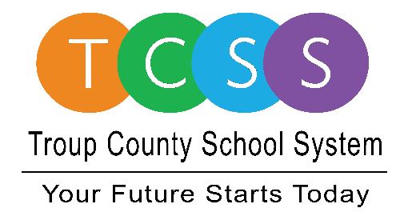
Yolanda Stephen, Director Public Relations
stephenyk@troup.org / troup.org
100 North Davis Rd, Building C / LaGrange, Georgia 30241
Office: 706.812.7900 / Fax: 706-812-7904

Story Release
FOR IMMEDIATE RELEASE

Gabby Wilkinson Graduates Despite a Personal Illness

LaGrange, GA., June 8, 2020 – Studying nursing at Spelman College is what Gabby Wilkinson is looking forward to in the fall after graduating from Callaway High School. Most of her studying was done at home due to a personal illness but that has not kept her from sharing a fun memory of classroom learning, “Ms. Mapp’s cooking class was always fun. We learned how to do different things and I am able to use what I learned in class now,” said Wilkinson.

Her favorite teacher is Mr. Christopher Herdener. She remembers his class because, Wilkinson said, “I never had a teacher – from when I came to school every day – to just motivate me with so many encouraging words and would always tell me to have faith in myself. If it wasn’t for him encouraging and motivating me, I probably wouldn’t have finished my work like I should have. It would have made a difference. He definitely played a huge role in my life.”

Hanging out with her friends made her high school matriculation special. Wilkinson said Callaway High is unique and it allowed her to make her way to a better future despite her illnesses during the school year. Now she does what most people have reverted to when it comes to hanging out with friends, she stays in contact by using social media and regular phone calls.

For incoming seniors, Wilkinson says to stay focused, “I would tell them to stay focused. Every grade counts. Be confident in yourself and understand it’s okay to make mistakes but to always remember to make wise decisions.”

About Troup County School System
Troup County School System is an accredited educational system with over 12,100 students in grades K-12. TCSS does offer a free Pre-K program at each elementary school. The system is comprised of eleven elementary schools, three middle schools, three high schools, one college and career academy, and one alternative learning center. Students within the school system are taught a rigorous and relevant curriculum that helps them make college and career choices beyond graduation and succeed in life. The system 2019 graduation rate is 86.6 percent. To learn more about Troup County School System, visit troup.org and the Troup County School System Facebook page.

###
Photos: Gabby Wilkinson

