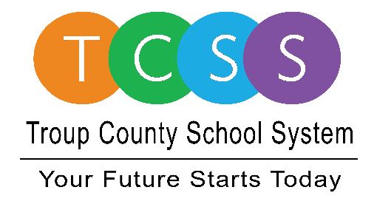
Yolanda Stephen, Director Public Relations
stephenyk@troup.org / troup.org
100 North Davis Rd, Building C / LaGrange, Georgia 30241
Office: 706.812.7900 / Fax: 706-812-7904

Story Release
FOR IMMEDIATE RELEASE

Behind the Mask Troup County Employees Get the Job Done

LaGrange, Ga., March 12, 2021 – As school system employees were prepping for a professional learning day this same time last year, there was a national health crisis brewing that would halt plans for teachers reviewing data, updating lesson plans, and preparing for the final push of the school year. Little did anyone know that students and staff wouldn’t grace the corridors of a classroom until the fall.

Since that time, Troup County School System (TCSS) administrators were in deep preparation for children to return to school – safely. The seven-member Board of Education even voted unanimously to mandate face coverings throughout the system. Partners in education and retired school teachers reached out to provide hand sanitizer and Clorox products for classroom teachers, handmade masks for kids, and donations for back-to-school supplies.

All the while, TCSS employees across the system were getting the job done…Behind the Mask:

- 381,874 meals served in the spring and summer
- 7,748 bus miles logged for Meals on Wheels
- Over $22,600 in cleaning supplies purchased
- 77,697 Canvas professional learning page views
- 900 floor spacing decals ordered for school offices and media centers
- Over 200 classrooms cleaned and fogged
- 1,165.51 employee hours logged for employees cleaning buildings

This week, TCSS is telling employees ‘thank you’ and highlighting their dedication to the students and parents of the school system through a social campaign entitled Behind the Mask.

Yolanda Stephen, TCSS Director of Public Relations stated, “We are mindful that many people are still experiencing different emotions about the effects of this year. We knew there had to be a way to capture the history and the work we have done in an impactful way.”

Behind the Mask yard signs have been posted throughout the county, employee photos and highlights are being shared on troup.org, a video sharing teacher and student accomplishments was created and is available for viewing on the system’s Facebook and Twitter page, and a digital thank you card was created for employees and community members to print or share on their personal social pages.

“The bottom line is that our employees are amazing. We had to collectively make adjustments very quickly, and we did,” she said. “When the school year ended a bit abruptly, we still delivered services to ensure kids were learning and eating healthy meals. As the school year started in August, while there was still apprehension nationally and locally, we forged through with unwavering commitment to provide a safe learning environment for students and each other,” Stephen noted.

She mentioned that the recognition comes at a time when school system employees are now
prepping for vaccinations almost a year-to-the-date of school closure and shut-downs. “March is when we would normally name our Teacher of the Year but we are bunking that tradition due to the state not holding the competition. Instead, we are thanking our employees for a job well done – behind the mask.”

About Troup County School System
Troup County School System is an accredited educational system with over 12,100 students in grades K-12. TCSS does offer a free Pre-K program at each elementary school. The system is comprised of eleven elementary schools, three middle schools, three high schools, one college and career academy, and one alternative learning center. Students within the school system are taught a rigorous and relevant curriculum that helps them make college and career choices beyond graduation and succeed in life. The system 2020 graduation rate is 85.9 percent. To learn more about Troup County School System, visit troup.org and the Troup County School System Facebook page.
###

