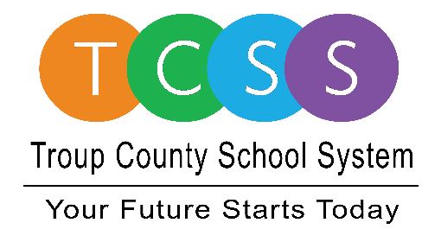
Yolanda Stephen, Director Public Relations
stephenyk@troup.org / troup.org
100 North Davis Rd, Building C / LaGrange, Georgia 30241
Office: 706.812.7900 / Fax: 706-812-7904

Story Release
FOR IMMEDIATE RELEASE

Troup County School System Partners with LaGrange Development Authority, City of LaGrange and Jackson Services to Offer Outdoor Senior Proms

LaGrange, Ga., March 3, 2021 – Today, Troup County School System (TCSS) officially announced they are working with the City of LaGrange, LaGrange Downtown Development Authority, and Jackson Services to bring all three high school proms to Sweetland Amphitheatre.

After postponing one high school prom date, the school system contacted the outdoor concert venue representatives. “Last year, our seniors were not able to have a prom and we wanted to really offer something different for this year’s senior class to remember. We also wanted it to be safe,” said Dr. Shumate, TCSS Superintendent. “When we reached out, all of these organizations came together, stepped right in, and said they would do what was needed for the seniors to have a memorable night. We thank them for helping us provide this opportunity.”

The annual end-of-year dances will be held three consecutive Saturdays in May under the big white tent used mainly for winter ice skating events:

- Saturday, May 1 – LaGrange High School
- Saturday, May 8 – Callaway High School
- Saturday, May 15 – Troup High School

A portable wooden dance floor will be rented to cover the brick that is currently in place at Sweetland. In addition, the concession area will offer food and drink items while the Del’Avant staff will assist as needed throughout the evening. To ensure there is enough outdoor covered space for an enjoyable night, Jackson Services will provide two additional tents - one air conditioned - and three portable air conditioning units to provide a cooling area for prom goers.

More details about prom times and logistics will be shared with students and parents in the coming weeks.

About Troup County School System
Troup County School System is an accredited educational system with over 12,100 students in grades K-12. TCSS does offer a free Pre-K program at each elementary school. The system is comprised of eleven elementary schools, three middle schools, three high schools, one college and career academy, and one alternative learning center. Students within the school system are taught a rigorous and relevant curriculum that helps them make college and career choices beyond graduation and succeed in life. The system 2020 graduation rate is 85.9 percent. To learn more about Troup County School System, visit troup.org and the Troup County School System Facebook page.

###

