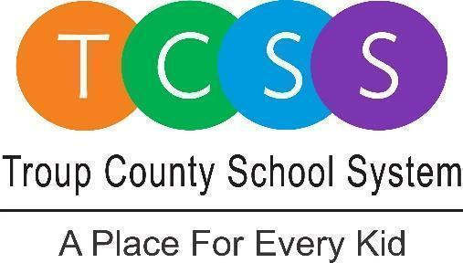
Irisha Goodman, Director of Public Relations
goodmani@troup.org / troup.org
100 North Davis Rd, Building C / LaGrange, Georgia 30241
Office: 706.812.7900 / Fax: 706-812-7904

Media Release
FOR IMMEDIATE RELEASE

Troup County School System Announces Teacher of the Year Finalists

LaGrange, Ga., February 3, 2023 –Troup County School (TCSS) Superintendent, Dr. Brian Shumate, surprised four teachers with flowers and a gift bag during the Teacher of the Year Surprise Patrol Friday morning. As Shumate, principals, family, co-workers, and friends entered their classrooms, the Teacher of the Year (TOTY) finalists learned they made it to the next local round of competition.

The division finalists are:

● Elementary Teacher of the Year
  - Layna Kemp: 2nd-grade teacher of all subjects at Long Cane Elementary

● Middle School Teacher of the Year
- Debbie Cox: 7th grade Life Science at Gardner Newman Middle School

● High School Teacher of the Year - We have a tie this year
- Laura Lee Pike: 9th grade World Literature, American Literature, and British Literature at Troup County Career Center

- Dr. Zelda Kitt: 9-12 grade ELA at The Hope Academy

"We are extremely proud of all our TOTY candidates, especially the four finalists recognized today. Daily, these teachers demonstrate a passion for learning and results, as seen by their interactions with students and their collaborations with their peers. This is one of the best parts of my job when we recognize our outstanding TCSS employees! I wish the four finalists a good luck." said Dr. Shumate.

These top four system finalists will now move on to the next phase of the competition for TOTY. The finalists will be judged by educational professionals who do not reside in Troup County. They will observe classroom instruction, conduct interviews, and review the finalist's written applications.

TCSS will announce one of the four finalists as the Troup County School System Teacher of the Year, and honor all school-level Teacher of the Year winners, at a special reception on Wednesday, March 22, 2023.

Dr. Linda Wood from Troup High School is the current TCSS Teacher of the Year. She is vying for the state-level honor, which will be announced in May.

About Troup County School System

Troup County School System is an accredited educational system with over 12,200 students in grades K-12. TCSS does offer a free Pre-K program at each elementary school. The system is comprised of eleven elementary schools, three middle schools, three high schools, one college and career academy, and one alternative learning center. Students within the school system are taught a rigorous and relevant curriculum that helps them make college and career choices beyond graduation. The system 2022 graduation rate is 85.9 percent. To learn more about Troup County School System, visit troup.org and the Troup County School System Facebook page.
###

