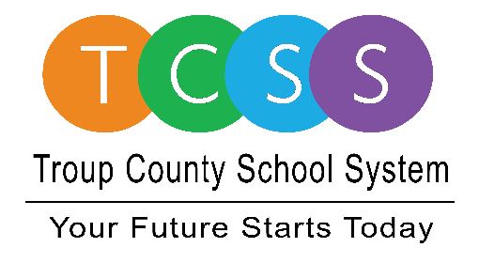
Yolanda Stephen, Director Public Relations
stephenyk@troup.org / troup.org
100 North Davis Rd, Building C / LaGrange, Georgia 30241
Office: 706.812.7900 / Fax: 706-812-7904

Story Release
FOR IMMEDIATE RELEASE

TCSS Elementary Kids Are Spending the Summer ‘Dreaming’

LaGrange, Ga., July 15, 2021 – With summer in full swing, students in grades kindergarten through sixth are enjoying the summer ‘Dreaming’ in the Dreamers Camp hosted by Troup County School System (TCSS). While learning reading and math, the students also enjoy art and the continuity of instruction to help prevent summer slide. The camp theme makes learning engaging and provides an element of fun and connection between all students in the program.

Nicole Kennedy, TCSS Parent and Family Engagement Coordinator stated, “After the shutdown from the pandemic and many of our students participating virtually this past school year, we wanted to make learning fun and enticing to encourage attendance. A summer learning committee was formed with Deana Brown, Elementary Curriculum Director, and TCSS employees to create a fun, robust learning experience. We didn't want it to be like a typical summer school. We wanted it to be more of a camp setting so we had campers (students) involved in the learning experience.”

The summer planning committee invited community guests, teachers and staff into the schools for “campfire time”. During this designated time, students would participate by singing songs, or reading lines in a storybook. They even had the pleasure of hearing some of the county’s best storytellers, including Debbie Burdette as Mamma Jama, Connie Askew, Jack Morman, Carol Cain, Kim Myers, Jo Beth Lanier, Gail Gordon, and Nicole Kennedy.

Kennedy stated, “We are so appreciative to these volunteers for spending time with our children this summer. This was the first time some of children have come back to school since COVID-19 started and we want our families to see that kids are safe in an environment that is socially, academically and emotionally strong for their children.”
Playing off the camp theme, recently, The Jungle Bus visited Franklin Forest Elementary School (FFES) students for a group activity. This mobile library visits schools, daycares, and other educational centers in the community throughout the school year. Wherever the Jungle Bus stops is where reading ambassadors Jungle Jama and Reading Ranger seek to spread the love of reading and instill the importance of reading in students. On the day of the visit, FFES students sat around a pretend campfire, they learned reading facts, happily sang The Jungle Bus jingle, and even read the beloved children’s book, Row, Row, Row Your Boat. After the group reading activity, each camper hopped onto The Jungle Bus and selected their own book to take home and read.

TCSS is also hosting summer learning programs for middle school and high school students, where similar programs on each grade level is being facilitated by certified educators in their respective subjects.

Dreamers Camp runs until the end of July and there are over 500 students enrolled throughout the county at each elementary school except Hollis Hand. Hollis Hand students are housed at Hillcrest due to a recent paving project. Camp is held each morning beginning at 8:30 a.m. and the students are released at 12:30 p.m. Transportation is provided and free breakfast and lunch is served daily.

As Reading Ranger and Jungle Jama told Franklin Forest students, “For future success in school and life, keep reading books.” These students, and more in summer camps throughout the county, will be able to continue developing their reading skills this summer thanks to their new books from the Jungle Bus,

About Troup County School System
Troup County School System is an accredited educational system with over 12,100 students in grades K-12. TCSS does offer a free Pre-K program at each elementary school. The system is comprised of eleven elementary schools, three middle schools, three high schools, one college and career academy, and one alternative learning center. Students within the school system are taught a rigorous and relevant curriculum that helps them make college and career choices beyond graduation and succeed in life. The system 2020 graduation rate is 85.9 percent. To learn more about Troup County School System, visit troup.org and the Troup County School System Facebook page.
###

