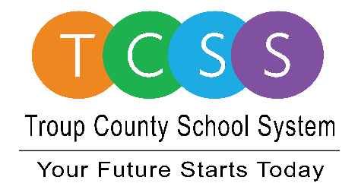
Yolanda Stephen, Director Public Relations
stephenyk@troup.org / troup.org
100 North Davis Rd, Building C / LaGrange, Georgia 30241
Office: 706.812.7900 / Fax: 706-812-7904

Story Release
FOR IMMEDIATE RELEASE

TCSS Receives Award for Stepping Up to Host Blood Drives

LaGrange, Ga., August 10, 2021 – When Troup County School System (TCSS) Superintendent Dr. Brian Shumate agreed to give blood last year during a school blood drive, he didn’t know that would spur more blood drives for the American Red Cross.

“It allowed five entities to come back on our blood drive circuit. It was a great showing Dr. Shumate’s picture giving blood because it was a catalyst. It showed other businesses that if a school system could do it then so could they,” noted Holly Winner, American Red Cross Executive Director. This meant more than anything considering businesses shut down and even if a blood drive was going to be held, there were no employees present on-site to participate.

“In a year, and now still, in a time when every unit of blood is so critical, having entities return to a regular schedule of blood donations made a big difference,” said Winner.

Johnny Williams, American Red Cross Account Manager, said what helped get the organization through the pandemic were churches and community blood drives. “Going into last school year, everything that typically runs in Troup County, ran. There were Covid precautions put into place and blood drives were held. I’ve got 13 counties that I collect blood in and Troup County was the only county I was able to collect. Troup County was a huge help.”

About Troup County School System
Troup County School System is an accredited educational system with over 12,100 students in grades K-12. TCSS does offer a free Pre-K program at each elementary school. The system is comprised of eleven elementary schools, three middle schools, three high schools, one college and career academy, and one alternative learning center. Students within the school system are taught a rigorous and relevant curriculum that helps them make college and career choices beyond graduation and succeed in life. The system 2020 graduation rate is 85.9 percent. To learn more about Troup County School System, visit troup.org and the Troup County School System Facebook page.
###

*Photo of Winner and Williams presenting award to Dr. Shumate.

