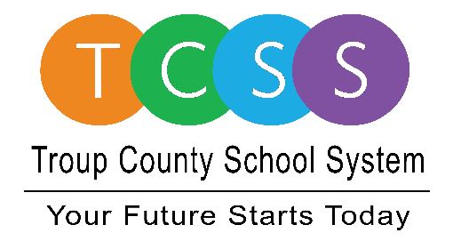
Yolanda Stephen, Director Public Relations
stephenyk@troup.org / troup.org
100 North Davis Rd, Building C / LaGrange, Georgia 30241
Office: 706.812.7900 / Fax: 706-812-7904

Story Release
FOR IMMEDIATE RELEASE

Three TCSS Students REACH for the Top

LaGrange, Ga., June 21, 2021 – While some students may be spending a few days at the beach, three Troup County School System (TCSS) rising ninth graders are scoring scholarships through the REACH Georgia (Realizing Educational Achievement Can Happen) scholarship program. They are:

- Macy Alivia Ogletree – Callaway Middle School
- Bryant Xavier Jimenez – Gardner Newman Middle School
- Dasoni Darrell Denson – Long Cane Middle School

In a ceremony hosted by TCSS, students and their parents signed a commitment to graduate for them to be eligible to receive $10,000 in grants to support their post-secondary education. Dr. Brian Shumate said, “This is a pivotal time for these students and they are going to need the help and support of their parents, us, and the community.”

With the addition of Ogletree, Jimenez, and Denson as REACH scholars, TCSS now has a total of seven eligible scholars. The students must maintain good grades, behavior and attendance throughout the program. In addition, TCSS is actively seeking community member mentors for each of the REACH scholars as a provision to the awarding of the grants. Seven mentors are needed to complete a one-hour monthly mentorship with their selected student for the duration of their high school career. Any interested mentor can reach out to the TCSS Secondary Curriculum Department at 706.812.7900 or email info@tcss.com for more information.

About Troup County School System
Troup County School System is an accredited educational system with over 12,100 students in grades K-12. TCSS does offer a free Pre-K program at each elementary school. The system is comprised of eleven elementary schools, three middle schools, three high schools, one college and career academy, and one alternative learning center. Students within the school system are taught a rigorous and relevant curriculum that helps them make college and career choices beyond graduation and succeed in life. The system 2020 graduation rate is 85.9 percent. To learn more about Troup County School System, visit troup.org and the Troup County School System Facebook page.
###

