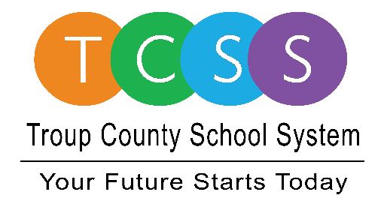
Yolanda Stephen, Director Public Relations
stephenyk@troup.org / troup.org
100 North Davis Rd, Building C / LaGrange, Georgia 30241
Office: 706.812.7900 / Fax: 706-812-7904

Story Release
FOR IMMEDIATE RELEASE

TCSS Celebrates School Lunch Hero Day

LaGrange, Ga., May 4, 2021 – Troup County School System is jumping in the celebration for school lunch heroes. In between preparing healthy meals for our students, adhering to strict nutrition standards, navigating student food allergies, and offering service with a smile, school nutrition professionals are true heroes.

This is the 8th Annual School Lunch Hero Day where TCSS takes a moment to showcase the difference school nutrition professionals make for every child who comes through the cafeteria or is eating in their home virtual classroom. Here are some fun facts about the

- Male cafeteria employees are known as ‘food dudes’.
- Large elementary schools open and prepare an average of 8 cans of fruit per day.
- Middle schools serve between 25 and 30 pizzas every day. That would be between 200-240 slices of pizza per day.
- School Nutrition staff only sit down on their break; the rest of the day is spent on their feet.
- Each school receives food trucks weekly; the average weight of the food that must be put away is 1,500 lbs for a small elementary school, 3,000 lbs for a large elementary school, 2,500 lbs for middle schools, and 3,000 lbs for high schools.
- Each morning the managers clean and sanitize the kitchen for an average of 20 minutes before they begin their day; in addition, each night the staff clean and sanitize the kitchen prior to leaving for the day.
- The average breakfast distribution at an elementary school is 250 per day; this is all done within 30 to 45 minutes every morning.

About Troup County School System
Troup County School System is an accredited educational system with over 12,100 students in grades K-12. TCSS does offer a free Pre-K program at each elementary school. The system is comprised of eleven elementary schools, three middle schools, three high schools, one college and career academy, and one alternative learning center. Students within the school system are taught a rigorous and relevant curriculum that helps them make college and career choices beyond graduation and succeed in life. The system 2020 graduation rate is 85.9 percent. To learn more about Troup County School System, visit troup.org and the Troup County School System Facebook page.
###

