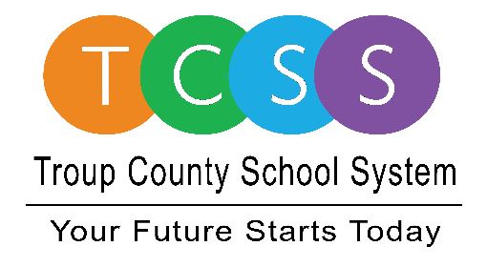
Yolanda Stephen, Director Public Relations
stephenyk@troup.org / troup.org
100 North Davis Rd, Building C / LaGrange, Georgia 30241
Office: 706.812.7900 / Fax: 706-812-7904

Story Release
FOR IMMEDIATE RELEASE

THINC Ahead Career-Awareness Expo Helps
Students and Regional Employers Get Ahead

LaGrange, GA., May 13, 2021 – THINC College & Career Academy (THINC) hosted its annual career-awareness expo last week after canceling the event last year due to the pandemic. This year’s event boasted a record high number of vendors with 34 organizations present to introduce high school students to careers they can pursue in Troup County.

“Thank you for doing this,” Mike McCollum, owner of Hog Heaven Restaurant in LaGrange, said about the in-person event. “THINC has been instrumental in helping us identify potential candidates for hospitality and now we can start rounding out our team with them.”

About 350 students, ranging from freshman to seniors, attended THINC Ahead. Students were asked to wear work-ready attire and to bring a copy of their resume if they were looking for a job. Although the expo’s main goal is to raise awareness about career paths and job opportunities in the community, at least four employers were conducting on-site interviews with students who are ready to go to work.

“This event is vital to teaching students about the wide variety of jobs available within different industries,” said Dr. Chris Williams, Principal at THINC. “Students learn about jobs in our community. They network with professionals. They talk about career paths and what they need to do to get there. It was great to see such a large turnout this year and to see everyone’s excitement about connecting again. This was the best THINC Ahead we’ve had yet!”

THINC Ahead is an annual workforce development initiative founded in 2015 by THINC College & Career Academy. THINC Ahead promotes career awareness and provides students with an opportunity to gain employment in their community. To get involved or request more information, contact Carrie Tomlin at tomlincl@troup.org.

About Troup County School System
Troup County School System is an accredited educational system with over 12,100 students in grades K-12. TCSS does offer a free Pre-K program at each elementary school. The system is comprised of eleven elementary schools, three middle schools, three high schools, one college and career academy, and one alternative learning center. Students within the school system are taught a rigorous and relevant curriculum that helps them make college and career choices beyond graduation and succeed in life. The system 2020 graduation rate is 85.9 percent. To learn more about Troup County School System, visit troup.org and the Troup County School System Facebook page.
###

