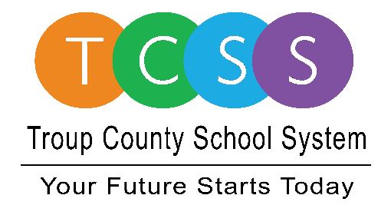
Yolanda Stephen, Director Public Relations
stephenyk@troup.org / troup.org
100 North Davis Rd, Building C / LaGrange, Georgia 30241
Office: 706.812.7900 / Fax: 706-812-7904

Story Release
FOR IMMEDIATE RELEASE

TCSS Bus Shop Employees Receive Thanks for 100% Pass Rate

LaGrange, Ga., April 12, 2021 - When the Troup County School System (TCSS) Bus Shop employees received a 100 percent pass rate on their annual state bus inspection, they were proud to share the news. Members of the team were invited to the Board of Education meeting and others received their certificates from Dr. Brian Shumate, TCSS Superintendent, in front of the administrative team during a weekly meeting.

This isn’t the first time bus shop employees have been lauded for high marks, but each time is well worth the hard work to keep students and employees safe while being transported to school and back home. The 165 bus fleet inspections were conducted by the Georgia Department of Public Health; the same officers one may see on the side of the highway inspecting 18-wheel trucks.

TCSS Director of Transportation, Chip Giles, is a former military logistics professional, “Our transportation employees received 100 percent three times in the last five years. The other two years they received a 99 percent. That is an outstanding accomplishment.” He credits professional bus shop leadership, excellent facilities, high standards, and the fact that the individuals who run the bus shop really enjoy working together as the keys for successful inspections.

Giles said, “I want to thank the men and women who work hard every day to keep our school buses maintained to such a high standard. This drive to excellence results in safer school buses for our children. This accomplishment is very hard to achieve and they deserve this recognition.”

About Troup County School System
Troup County School System is an accredited educational system with over 12,100 students in grades K-12. TCSS does offer a free Pre-K program at each elementary school. The system is comprised of eleven elementary schools, three middle schools, three high schools, one college and career academy, and one alternative learning center. Students within the school system are taught a rigorous and relevant curriculum that helps them make college and career choices beyond graduation and succeed in life. The system 2020 graduation rate is 85.9 percent. To learn more about Troup County School System, visit troup.org and the Troup County School System Facebook page.
###

Three Photos: Shop Employees Inspect TCSS School Buses

